Name: _________________________ Date: ______________ #: __________

Grade 3 Fluency Practice: Number Five

- Which shape is defined as a quadrilateral?  - Hexagon  - Trapezoid  - Triangle  - Pentagon | - Write the number of sides and angles the following shapes have.  Sides Angles  Hexagon:  Trapezoid:  Triangle:  Pentagon:  Circle:
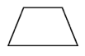  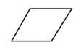  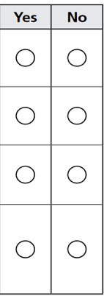  - Is the shape both a parallelogram and a rectangle? | - Study the piece of paper with a perimeter of 40 inches and a length of 12 inches. What is the width of the piece of paper?  12 in
- Which figures have the same perimeter? _____________  4 in.  6 in 6 in  2 in  5 in  5 in | - What number goes in the box to make the equation true?  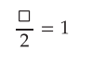
- What number goes in the box to make the equation true?  X 6 = 54  11 x = 121 | - What is the sum of 759 and 294?
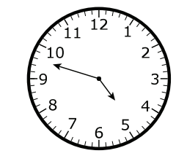  - Suzie started her homework at the time shown on the clock. What time did Suzie start her homework? | 10. Rob brought juice boxes to soccer practice. He brought 4 packs of boxes. Each pack had 10 bottles. There were 7 bottles left at the end of practice. How many bottles of water were used during practice?
11. What other equation can be used to solve 56 $÷7=a?$ | 12. What is the difference between 700 and 359?

